Day 3: Social Media Content Agent (Part-1)
Opening & Homework Review (5 min)
- Chat Activity: “Share in chat: What was your favorite moment or biggest challenge from building last session’s automation?”

Theory Section: What are HTTP and APIs?
- HTTP (HyperText Transfer Protocol):
  - The “language” web browsers, automation tools, and apps use to talk to each other—like mailing a letter and getting a reply.
  - Super beginner video:
  - What is HTTP?
- API (Application Programming Interface):
  - APIs are like restaurant menus. You order (send a request) and get exactly what you want delivered (the response).
  - API video:
  - What is an API?
Chat Question: In your own words in chat, what is HTTP, and what is an API? Explain in one sentence.

1. APIs and HTTP: The Food Delivery Example
This is the cycle of every action your Agent takes outside its brain:
Concept | Definition | Relatable Analogy & Practical Example
API (Application Programming Interface) | The bridge that lets two different software systems communicate and share data. | The Food Delivery App (Uber Eats): You (the Agent) tell the App (the API) what you want, and it handles the communication with the restaurant (the server).
HTTP Request | The foundational protocol used to structure requests and responses over the internet. | The Digital Order Slip: The specific, formatted message the App sends to the kitchen (the server) to place your order.
HTTP GET | Requests data from a specified resource (read-only operation). | Checking a Menu: The Agent uses GET to retrieve the latest stock prices or check a customer's order history from a database.
HTTP POST | Submits data to be processed, usually causing a change in state on the server. | Placing the Order: The Agent uses POST to submit a form, create a new record in a CRM, or send a full email.

The Request-Response Cycle (API Call Flow)
This is the universal flow that happens every time an Agent uses a Tool:
- Client/Agent sends an HTTP Request (The Order).
- The Server/System receives and processes the request.
- The Server/System sends back an HTTP Response (The Data/Confirmation).
- The Client/Agent receives the response.

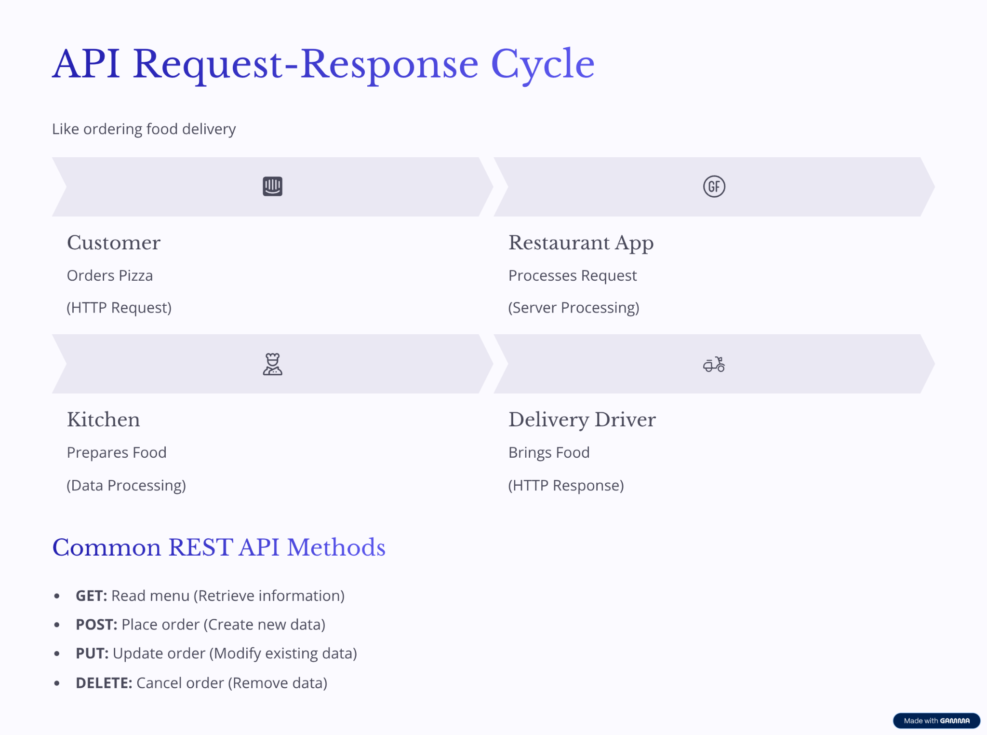

What We’re Building Today
- Google Sheets for students to submit content ideas (topic, audience, style, etc.).
- Automation sends these ideas to OpenAI, which generates a detailed, platform-ready script.
- Each student receives their personalized script—ready for social, video, or campaign use.

This is Part 1 of building a Social Media Agent with your own Avatar.

Demo: Google Sheets to OpenAI Script Generation Setup Steps:

Step 1: Go to ChatGPT and type this prompt. Understand how to build this in Zapier.

Role: You are an expert in automation workflows for video content, and creating workflows on Zapier.

Context: I am trying to create a workflow on Zapier that does this

I write my idea, what kind of video I want to create for my brand, I give specifications of what kind of actors, content, messaging, video format I want in 50 words or so, product Image, and I want AI to a) write a script for me, and b) create the video for me.

Task: Give me a step by step workflow on Zapier. Please include every small detail of how to build the workflow.

Assume I am a 10 year old who doesn’t know anything about automation or how to build things on Zapier.

Step 2: Create an excel sheet with the columns: https://docs.google.com/spreadsheets/d/18EoCMiUYUsdU_L_smpInPdp8omDgyHXNSOb9AtZXA5g/edit?usp=sharing

Step 3: Upload an Image of the product on Cloudinary and get the URL

Go to Cloudinary and login with your google account
Download your product Image
Go to the assets section in Cloudinary and upload the Image

Step 4: Create the data in the google sheet

https://docs.google.com/spreadsheets/d/18EoCMiUYUsdU_L_smpInPdp8omDgyHXNSOb9AtZXA5g/edit?usp=sharing

Step 5: Create the Trigger for starting the workflow
Setup Google Sheets Trigger

Step 6: Create the Action for Writing the Script
Choose ChatGPT

Step 7: Create a system and user message in ChatGPT

Role: You are an expert at creating UGC Video Content Using Veo 3 (fast) for e-commerce brands

Context: I work for a brand called Colgate, and I am trying to create social media content for my Instagram channel. I want UGC videos of my brand.

Here is what will I provide as an Input: It will be from a Google Sheet where I will enter these details every time I want a new video

What kind of video I want to create? (messaging, actors, any other specifications) | Who is my target audience? | Product Image | Video Specifications

And I want ChatGPT to write a Video Script for me for 6 Sec videos on Veo 3.

I am providing this input in Zapier. I want to create a no code Automation workflow

Task: I want ChatGPT to write a System Message and a User Message for me for this specific task.

User Message: should have JSon formatting for the columns/headers in excel sheet which will be the Input for Open AI Conversation Node. Make sure the Json structure is formatted correctly.

System Message should have detailed instructions including examples of how I want my output.

Output Example: I want my scripts to focus on emotions, and the design of my tooth brush, how its different from regular ones, and focus on like emotional storytelling specific to that target example.

Constraints: Just make sure its optimized for my Instagram account.

Step 8: Connect the data back to a google sheet

Student Activity: Build & Test Your Own Prompt (30 min)
- Create the workflow in Zapier
- Students submit their own ideas/form entries.
- Experiment with different tones, audiences, and purposes.
- Share the best (or funniest, or most on-brand) scripts in chat for group voting!

Please remember your groups, we will be using same groups for tomorrow also

Advanced/Optional: Script Variants (for fast finishers)
- Challenge: Edit the prompt to have OpenAI generate three variants (for YouTube, Instagram, WhatsApp blast, etc.), each with slight format/style tweaks.

Wrap-Up & Key Takeaways
- You learned: The basics of HTTP, APIs, and how they power automations.
- You can now turn any idea into a professional script (using zero manual writing).
- Prompt design = outcome quality.

Chat Reflection: “After today, what’s one piece of content you wish AI would write for you every week?”
Preview:
Tomorrow, you’ll take your scripts and automatically turn them into shareable, branded videos… with your own AI avatar!

